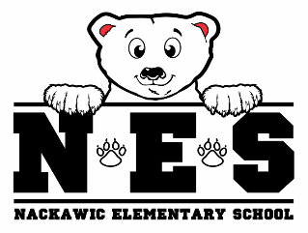 | Name:_____________  Class: _____________  Date: _____________ | Name:_____________  Class: _____________  Date: _____________ | Name:_____________  Class: _____________  Date: _____________ | Name:_____________  Class: _____________  Date: _____________
MONDAY | TUESDAY | WEDNESDAY | THURSDAY | FRIDAY
All paper orders must be in by Monday at 9:00 am for the week.  All online orders must be placed by Sunday evening of each week.  No late orders will be accepted.  If a child is away  and not able to  receive the order it will be carried over for the next week.  Payment online preferred.  Cash and cheques  accepted. Please send correct change or make cheques out to Nackawic Elementary School.  Please fill out name,  class and date at top of  each order slip. Slips  will be cut apart.  Attach payment to order form.  Please circle choices  clearly.  Please use one order form per child.  If you need more  menus please check  this box | Milk Only | Nackawic Golf Club and Restaurant | Robin’s | Milk Only
 |  | Wrap and  Veggie Sticks  Select Kind: (circle)  Roasted Turkey  Chicken  Veggie  __________________  Circle toppings:  Lettuce  Onions  Tomatoes  Cucumbers  Green Peppers  Mayo  Ranch Dressing | Sandwich &  Orange Slices.  Bread: (circle)  White  Whole Wheat  Select kind: (circle)  Steak  Ham  Bacon  Turkey  __________________  Circle toppings:  Cheese  Onions  Tomatoes  Lettuce  Pickle  Mayo  Mustard  Honey Mustard
 | Price: (Circle)  50¢ just milk  White Chocolate | Price: (Circle)  $5.00 meal with milk  $4.50 meal without milk  50¢ just milk  White Chocolate | Price: (Circle)  $5.00 meal with milk  $4.50 meal without milk  50¢ just milk  White Chocolate | Price: (Circle)  50¢ just milk  White Chocolate
Nackawic Elementary School Menu Order Form
When placing an order, please complete menu regardless of payment
PLEASE CHECK: ( ) Paid Online ( ) Payment Attached

